Object Usage Sensor

Preliminary Specification

*Revision 0.01  
June 2014*

1. Sensor state definition

The object usage sensor will continuously compute an overall “motion count” value. This value should be similar to the area under the curve of a high passed accelerometer signal, where each the sensor’s three axis are filtered indepenentently and then results are added together. The goal is to remove the gravitational component of the sensor, so that only true motion is measured.

Even better would be a band passed signal, so that undesirable motion spikes are removed, but that is probably too complex for firmware implementation in this case. We could low pass then high pass.

For a basic high pass filter algorithm, see:

<http://en.wikipedia.org/wiki/High-pass_filter#Algorithmic_implementation>

The goal of the filter is to cut out the gravitational component and center each axis on 0. Then you can compute

Count = SUM_over_N_signals(ABS(x) + ABS(y) + ABS(z)) where N should be SAMPLING_RATE*2s. Ideally we’d use a sampling rate of 10Hz, so N might be 20.

(We might be able to get away with 5 Hz … we’ll need to test.)

The Count value range will depend upon what the range of the accelemeter is. (Can we change it?) It should be set to +/- 2g if that is an option, otherwise +/- 4g, otherwise 6 or then 8.

State: Still

The sensor is still if

Count < STILL_THRESHOLD

where STILL_THRESHOLD will be set based on experimentation and dependent on the inherenet sensor noise.

State: Moving   
  
Count < MOVING_THRESHOLD

where MOVING_THRESHOLD > STILL THRESHOLD and will be set based on experimentation

State: VigorousMoving

Count < VIGOROUS_MOVING_THRESHOLD

where VIGOROUS_MOVING_THRESHOLD > MOVING THRESHOLD and will be set based on experimentation

2. Broadcast states

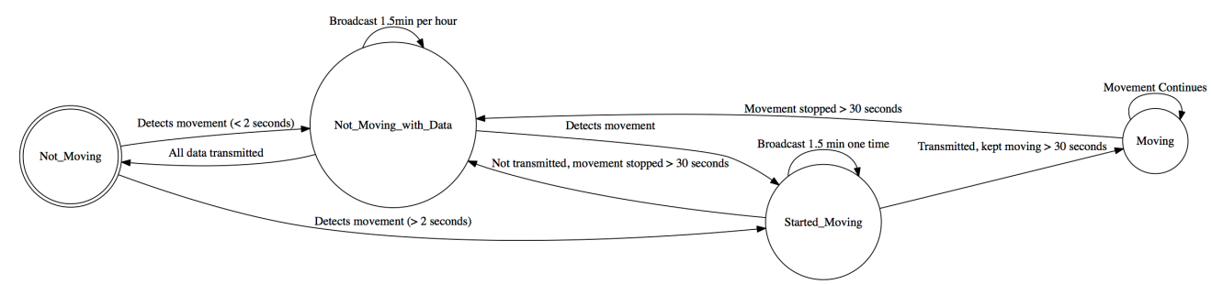

I think the states are:

Not moving – no data to transmit (just change the name)

Not moving – data to transmit (there was a motion event but the phone never grabbed it. So we want to store as much info as possible about the time it started, how long it lasted, and when it ended. What we can store depends on how you decide to store information. You will need to sum up data over longer periods of time than 2s. You won’t be able to store every 2s of data reading. Keep in mind we could have this pattern: object moved a few seconds. Still for an hour. Object moved a few seconds. Still for another hour. Phone comes back in range and we want to know as much as possible about the two events.)

StartedMoving – data to transmit (When something started moving we want to get that info to the phone. But until the phone comes in range, it should store info about that motion. If it stops moving and hasn’t transmitted data, go to not moving.

Moving – don’t transmit until stop (This is the case where it started moving and successfully transmitted this info but motion continues so that we don’t want to continue transmitting. Instead it should store the motion data (as much as possible, same as above) and then when several counts of not moving are observed, it should change the name to transmit.

Can you adapt the below to handle the above?

2.1 Object Usage Sensor Not moving

The OUS would use the default name, which is a string that contains enough information to determine the state of the sensor without connecting, where each string component is separated by a “_” character:

|  |  |  |  |
| --- | --- | --- | --- |
| **OUS** | **ID** | **Battery Level** | **Movement Def** |
| Text “OUS” | 8-digit alpha-numeric hex | Bxx (xx indicate the battery percentage) | NM (No movement) |

For example, **OUS_00000001_B78_NM** indicates this is the sensor with ID 1, and the current battery level is 78% and there has been no movement observed that has not already been transmitted to a receiving device. **OUS_08DF8321_B99_NM** indicates the sensor with ID “08DF8321” (or 148865825 decimal), and the current battery level is 99% and there has been no movement observed that has not already been transmitted to a receiving device.

To conserve battery, the sensor’s radio will only turned on once per hour and broadcast the sensor name for duration of 1.5 minutes (allowing enough time for the phone to detect it, if the phone is cycling 1/min). This is used as a “keep alive” signal, so a phone can keep track of which sensors are in the environment and signal the user if the battery is getting low or the sensor has not been heard from in a long time.

2.2 Object Usage Sensor not moving with data to transmit

The OUS would change the name to the following:

|  |  |  |  |
| --- | --- | --- | --- |
| **OUS** | **ID** | **Battery Level** | **Movement Def** |
| Text “OUS” | 8-digit alpha-numeric | Bxx (xx indicate the battery percentage) | MD (Moving Data collected) |

For example, **OUS_08DF8321_B78_MD** indicates the previously mentioned sensor is not moving currently, but has data to transmit. The radio will be on for 1.5 minutes waiting for the phone to read the data. After all the data successfully transmitted, the name will be changed back to what mentioned in 2.1.

2.3 Object Usage Sensor started moving

The OUS would change the name to as following:

|  |  |  |  |
| --- | --- | --- | --- |
| **OUS** | **ID** | **Battery Level** | **Movement Def** |
| Text “OUS” | 8-digit alpha-numeric | Bxx (xx indicate the battery percentage) | SM(Started Moving) |

For example, **OUS_08DF8321_B78_SM** indicates the sensor has detected a movement longer than 2 seconds. The radio will be on the broadcasting mode for 1.5 minutes to notify the phone, the phone will connect to read the data. If the sensor kept moving for at least 30 seconds, the sensor would goto the “Moving” state; if the sensor movement is less than 30 seconds, and then kept stable for at least 30 seconds, it would go to the “Not moving with Data” state.

2.4 Object Usage Sensor moving

The OUS would change the name to as following:

|  |  |  |  |
| --- | --- | --- | --- |
| **OUS** | **ID** | **Battery Level** | **Movement Def** |
| Text “OUS” | 8-digit alpha-numeric | Bxx (xx indicate the battery percentage) | CM( Continuously Moving) |

This only occurs after the “Started Moving” state, if the movement is longer than 30 seconds, the sensor would change the name, for example **OUS_08DF8321_B78_CM** tonotify the phone not to connect to it. Once the movement stopped for at least 30 seconds, it would go to the “Not Moving with Data” state.